Assignment #3: [Binary Trees]
Subject: CPS-331 Data Structure and Algorithm Course: BESE-15 A
Lab Instructor: Nausheen Date: December 9, 2010

SUBMISSION & VIVA: Next Lab i.e. 23rd December, 2010

TASK

- For a binary tree, write an algorithm to count the:
  - Number of nodes with degree 2.
  - Number of nodes with degree 1.
  - Number of nodes with degree 0.
  - Number of edges in a binary tree.

- The swap operation on binary tree can be done by interchanging left and right children of every node. For example, following figure illustrates the swap operation on a binary tree. Write code for method SWAPTREE(T) to obtain the swap of a binary tree T.

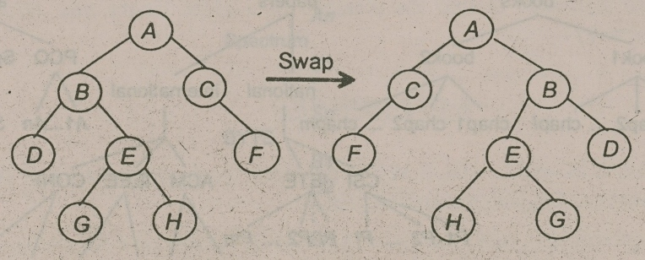
Figure: Swap Operation of Binary Tree

